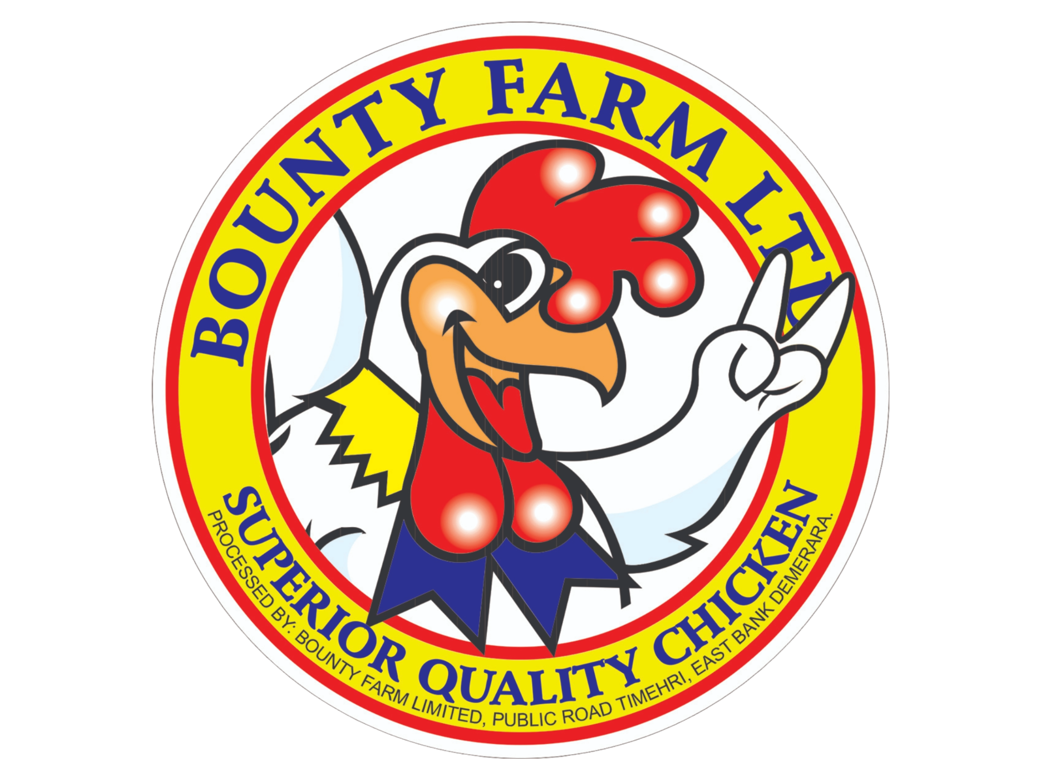
YOUR BUSINESS/COMPANY
DOCUMENT CONTROL PROCEDURE
DOCUMENT APPROVAL
Reviewed by: |  | Date:
Approved by: |  | Date:
 | Quality Manager

AMENDMENT LOG
REVISION # | DATE | AMENDMENTS | PAGES | SECTIONS | AUTHOR
01 | 07/11/2024 | First Issue | All | All | DP
02 | 27/06/2025 | 1. Definitions of Procedure and Records moved to 6.1 with updated document types.  2. The format of the DCN reflects document type updates.  3. Header reflects new procedure  4. Communication Section added | 3 - 5  All (Headers)  10 | 6.1  6.2 | SG

DISTRIBUTION
# | Document | Location/Holder
YOUR-PRO-01-IMS | Document Control Procedure

1. PURPOSE
This procedure describes the systems used at the YOUR BUSINESS/COMPANY for controlling all documents that are utilized by YOUR BUSINESS/COMPANY. Documents required by the quality management system must be controlled. The purpose of this procedure is to define the controls required:
- To ensure that changes and the current revision status of documents are identified.
- To ensure that relevant versions of applicable documents are available at points of use.
- To ensure that documents remain legible and readily identifiable.
- To ensure that documents of external origin are identified and their distribution controlled, and
- To prevent the unintended use of obsolete documents, and to apply suitable identification to them if they are retained for any purpose

2. SCOPE
This procedure addresses all documents including procedures, process diagrams, forms, records, checklist, policies, risk assessments, manuals that form part of YOUR BUSINESS/COMPANY Documentation.

3. RESPONSIBILITIES
The Quality Assurance Manager (QA) is responsible for:
- Final review documents.
- Recalling and archiving obsolete documents.
- Drafting and reviewing documentation pertaining to their function and interfaces.
- Maintaining a controlled copy of approved documents.
- Maintaining and controlling the Master List.
- Providing training for the employees pertaining to the Standard Operating Procedures.
The CEO is responsible for:
- 3.2.1 Reviewing and Approving all Documents
All Staff are tasked with:
- Making recommendations for the creation or revision of documents.
- Prepare and review documents as assigned by the Quality Control Manager.
- Comply with all document policies and procedures.

4. REFERENCES
- ISO 9001:2015 – Quality Management Systems

5. DEFINITIONS
- Controlled Documents – documents that are currently authorized, officially tracked, updated and archived when obsolete.
- Obsolete documents – documents that are not current.
- Draft – document that has not been approved.

6. PROCESS DESCRIPTION
6.1 Documentation System
- YOUR BUSINESS/COMPANY establishes, implements and maintains a documented system for all documents that are required for its operation and compliance to local and international standards followed by the company.
- YOUR BUSINESS/COMPANY has established and documented its system as follows:
  - Policies: Statements of intent and commitment by top management.
Policies outline YOUR BUSINESS/COMPANY’s dedication to meeting standards, ensuring quality, complying with legal and regulatory requirements, and continuously improving performance across QHSE and animal welfare domains. Code = POL
  - Procedures: Step-by-step instructions detailing how specific activities are performed.
They define responsibilities, sequences, methods, and controls needed to carry out operational and support processes consistently, safely, and in compliance with set standards. Code = PRO
  - Diagrams: Visual representations of workflows, interactions, and system logic.
These include flowcharts, sequence diagrams, and process interaction models that clarify the interdependence between processes and guide operational decision-making and alignment. Code = DIA
  - Manual: A top-level document that summarizes the structure of the management system.
It defines the scope, core policies, objectives, process architecture, roles, and references to supporting documents. The manual serves as a roadmap for how the organization ensures conformity and continual improvement.

  - Forms: Standardized documents used to capture, generate, or verify specific information.
Forms ensure activities are documented accurately and consistently, and they serve as evidence of compliance, traceability, and operational control. Code = FRM
  - Registers: Systematic logs used to record and track important data over time.
Registers provide ongoing records such as non-conformities, incidents, training, risk assessments, and equipment calibration. They are essential for monitoring trends and making data-driven improvements. Code = RGS
  - Templates: Preformatted documents that provide structure for reports and records.
Templates ensure consistency in documentation such as incident investigations, management reviews, or animal welfare audits. They guide staff in including all required elements for effective reporting. Code = TMP
  - Records: Completed documents that serve as objective evidence of activities performed.
Records are the final output of forms, checklists, or monitoring tools. They confirm that procedures were followed, standards were met, and controls were applied—supporting audits, traceability, legal defense, and performance review. Code NOT APPLICABLE as each file takes code of its respective document type.
- The Quality Assurance/Control Manager creates, reviews and establishes all documentation and ensures that all documents are consistent, accurate and kept up to date.
- The Managing Director and/or the CEO approve and authorize the use of all documentation.
- All documents are controlled with a Document Control Number, Version Number, Creation Date, Revision Date and Approval Date. This information is placed in a tabular format and included in the heading of all pages except for the cover page

6.2 Documentation System
All documents within YOUR BUSINESS/COMPANY Integrated Management System (IMS) shall be uniquely identified to ensure traceability, consistency, and proper version control. Each controlled document must display the following identification elements on every page, typically in the footer or header section:
- Document Control Number (DCN): A structured alphanumeric code following the format: BPF-[DOC TYPE]-[SEQ NO.]-[DEPT/IMS] (e.g., BPF-PRO-01-IMS),
which identifies the document type (e.g., Policy, Procedure, Form), sequence number, and system or department origin. This documents example is: DCN: BPF-PRO-01-IMS
- Document Title: The official name of the document (e.g., Document Control Procedure) must appear prominently at the top of the first page and in the header/footer of all pages.
- Version Number: Indicates the current approved version of the document
(e.g., Version 01). Any change, whether major or minor, must trigger an update to the version number following the version control protocol.
- Page Numbering: All documents must show page numbers in the format Page X of Y to maintain document integrity and completeness.
- Creation and Revision Dates: Each document must indicate its original creation date and the date of the most recent revision. These dates ensure that users are referring to the most current version.
- Prepared/Reviewed/Approved By: The names and positions of individuals responsible for preparing, reviewing, and approving the document must be clearly recorded, along with the corresponding dates.
- Company Branding: All official documents must include YOUR BUSINESS/COMPANY logo to authenticate the document’s origin and ownership.

6.3 Creation, Approval and Issue of documents
- Any YOUR BUSINESS/COMPANY’s employee or contractor may identify and request the need for a new document.
- The Quality Control/Assurance Manager/ Supervisor shall be consulted on the need for any documentation. He/She shall then verify if there is a document already existing within the Management System meeting the requirements of the request.
- Where no suitable document exists the QA/QC Manager/Supervisor shall arrange for the development of the new document. The requirement for new or additional documents may be based on, but not limited to:
  - Legislative requirements;
  - Suggestions from workers;
  - Risk Assessments
  - System failures reported or identified during incident investigations;
  - Internal or external audit findings;
  - Outcomes of workplace inspections and monitoring;
  - New product development;
  - Industry or organizational best practice; or
  - Changes in activities, process, equipment and or structure.
- All documents of the company’s operations are approved by the Production Manager and recorded on the Approval Sheet.
- All approved documents are maintained on the Master list by the QA/QC Supervisor.
- This list identifies all current revisions, location, and approving signatures.
- When a document has been revised, the old revision is deleted from the Document Master List, the current revision is added.

6.4 Review/Change of Document
- Changes to documents shall be reviewed and approved by the QA/QC Manager or other personnel specifically designated by the QA/QC Manager or the CEO.
- Persons designated will be provided with access to all pertinent background information.
- Review of documents occurs every three years at the management reviews or as deemed necessary to ensure the continuing stability and compliance of the company operations and standards. Reviews may be scheduled or unscheduled.
- The review shall ensure that the following is considered:
  - The continuing suitability and relevance of the documentation;
  - The accuracy and clarity of the documentation;
  - Compliance with current legislative & customer requirements;
  - The effectiveness of the document in achieving desired outcomes;
  - Identified areas requiring improvement;
  - The creating of any new documents and removal of obsolete documents; and
  - The status / currency of any attachments / references included in the documents.
- Each time a document is revised, the revision/ Issue number changes as appropriate.
- Each issue cancels and supersedes all previous issues and amendments. The amendment lists all the amendments to the latest issue of the Document.
- Amendments will not be implemented until the relevant section has been rewritten (amended), approved by the Managing Director or Quality Manager and issued.
- The QA/QC Manager distributes amendments and reissues the relevant document to all registered holders.
- The old document will be stamped “obsolete” and removed from all points of issue or use and the newly revised document will be issued.
- The Document Master List is then updated.
- Obsolete Documents are controlled as per section 6.5.
- Training of revised documents is scheduled and carried out by the QA/QC Manager or Deputy as necessary.
- The revised document is issued / distributed to copyholders as per Approval Sheet.
- It is the responsibility of the users of the documents to ensure that they remain legible and readily identifiable. If a problem is found with a document, the QC/QA Manager should be informed immediately.
6.5 Obsolete Documents
- Obsolete documents are those that are not in use. These documents are removed from point of use and destroyed except for those retained for either legal or knowledge preservation purposes, they are kept separately from documents that are in use.
- The label “OBSOLETE” is applied either by using stamp and pad / written or watermark as appropriate.
- Electronic versions are deleted; hard copies are shredded.
6.6 Document Storage & Access
- Documents, Records may be stored as either Softcopy (electronic) or Hardcopy.
- All electronic documentations are stored on the CompanyServer.
- The computers used to maintain documents are password protected with limited access.
- Each electronically stored document is further protected via password to prevent unauthorized access or modifications.
- Only Portable Document Format (PDF) documentation is shared electronically. This prevents unauthorized changes being made to the documents.
- When changes are made to a document, the newly revised documents are stored in the controlled folder with the same name but different revision number.
- The old document is watermarked obsolete and moved to the archive/obsolete folder. Documents on electronic storage media are stored for three (3) years.
- Hardcopy documents/records are stored in a designated filing cabinet within the Company Office, with restricted access.
- Records generated may be in the form of hardcopy or electronic media. Records must be stored in an orderly manner, either alphabetical or numerical, be easily identifiable to facilitate their efficient and effective retrieval / replacement by any authorized person for purposes such as:
  - Analysis / investigation;
  - Internal / external evaluation;
  - Evidence of legal compliance;
  - Evaluation and review; and
  - Training needs.
- Records shall be stored; retained for two years.
- Electronic documents/records are backed up on a weekly basis.
- Access to documents must be granted by the QA/QC Supervisor or the CEO. Only the QA/QC Supervisor or CEO has the authority to duplicate any document or record.
- Members of regulatory agencies, customers or their representative shall be granted access to relevant documentation/records in order to aid in the completion of audits or investigations. Access to documents / records shall be granted based on the scope of the activity (audit/investigation).

6.7 External Documents
- External documents include but is not limited to:
  - International Standards
  - Legal Requirements
  - Text books and Journals
  - Equipment Manual
  - Brand Product Specification
- All copies of branded documents and specifications shall have confidentiality statements such as, “Confidential”, Propriety Information” or as appropriate.

7. COMMUNICATION
All staff shall be made aware of the contents, purpose, and relevance of this document through appropriate means, including but not limited to training sessions, departmental briefings, controlled document distribution, and digital access. The relevant and responsible persons—such as department heads, QMS coordinators, and supervisors—are accountable for ensuring that this document is effectively communicated, understood, and applied within their areas of responsibility.
Proper communication ensures alignment with the Quality Management System and promotes organization-wide compliance, awareness, and continuous improvement.

